Roswell Cycling Festival
Kids’ Criterium
New Course! New Age Limit 6 Years Old!
May 15, 2016
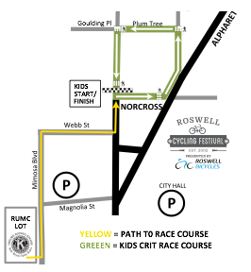
The Kids’ Criterium is an integral component of the Roswell Cycling Festival. The Criterium race is open to all children age 6 and above who participate in the Roswell Kiwanis Bicycle Safety Rodeo held in the Roswell United Methodist Church parking lot. While children as young as age 6 are welcome, parents are encouraged to be familiar with the route and judge whether their children possess adequate cycling skills to participate. The children will assemble at the Rodeo at 4:45 PM to ride their bicycles to the Criterium course, escorted by Roswell police officers. Parents and siblings not participating in the race will be able to walk to the start following the racers. The Kid’s Criterium will begin at approximately 5:00 PM and will be one lap of a course beginning on Norcross Street at Canton Street. The riders will race east on Norcross Street, turn left onto Alpharetta Street, left onto Green Street, left onto Plum Tree Street, and left onto Canton Street, finishing at the intersection of Canton and Norcross Streets. The children will be racing on the same course used by the adult racers; however, the course will be shortened by using Plum Tree Street. The fact that the route is a loop will allow parents to cheer their children on at the start, and stay in place to observe the finish. This year’s modifications have been designed to promote safety and make the event more convenient for parents. The yellow route indicates the approach to the race start and the green route indicates the race course proper.

