- Fun for every ride level!
- Raffle for Home Décor Cycling items.
- Refreshments before and after the ride.
This is one of the areas most popular
rides. With three different routes through beautiful Roswell (from easy to challenging) and four group levels, this ride is for riders of all abilities—from first timers to Cat 1-2 riders, and everything in between. This ride has it all: from flats along the Chattahoochee River to optional, spectacular climbs (1500 ft of ascent) that can challenge the best rider. Something for every cyclist!
Please visit www.bikeroswell.com
for

May 12th at 6:30pm
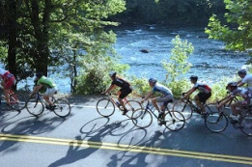
Bike Roswell! THURSDAY NIGHT RIDE
Hosted by Giovanni Tile Design Team
START/FINISH: Riverside Park, 575 Riverside Road, Roswell, GA 30076
Start time: 6:30pm
A Group - 20-23 mpg avg - 25 miles
B Group -18-21 mpg avg - 20 or 25 miles
C Group -16-17 mpg avg - 20 or 25 miles NO DROP ride.
D Group - 10-14 mpg avg - 12 miles partial road mostly trail. NO DROP ride.

Come out and get your ride on…
Be a part of the fun in support of the
Bike Roswell! & the Roswell Cycling Festival!
Go to event website at RoswellCyclingFestival.com for more info.
A few of the Cycling Home Décor Raffle items!!!
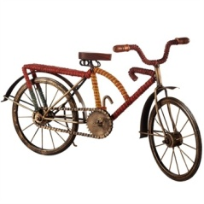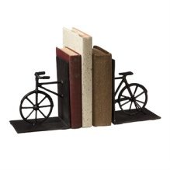
So, bring some CA$H to buy a ticket!

