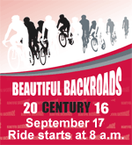

Ride Beautiful Backroads Century with Team Bike Roswell!

September 17th 2016
Bike Roswell! Members’ receive $10 off the registration fee with code if registered before September 1st!
For more information on Team Bike Roswell! rides Beautiful Backroads Century (BBC) please visit
http://www.bikeroswell.com

