Traffic Safety 101 / Safe Cycling

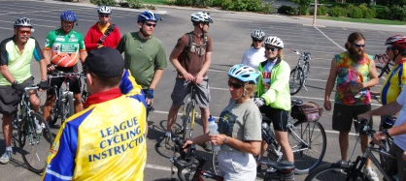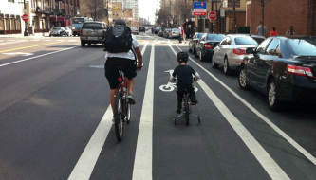

Saturday May 7, 2016
8:00am - 6:00pm
(Rain date Sunday May 8)

Roswell-Alpharetta Public Safety Training Center
11565 Maxwell Rd, Alpharetta, GA 30009

Are you ready to be a ride leader for your club?
Do you want to increase your knowledge and expertise in the art and science of bicycling? Are you interested in becoming an official League Cycling Instructor (LCI)?
Then, this is for you!

Morning session Classroom
- Bicycle Basics (types of bikes, maintenance, the bike, etc.)
- Biking in Traffic (rules of the road, crash data)
- Enjoying the Ride (etiquette, equipment, riding with motorists)

Lunch break - approximately 30 minutes

Afternoon session Road
- Bike Handling and Avoidance Maneuvers
- Road Ride

Alternative online training is available instead of the morning classroom section.
For more information, contact Nedra Deadwyler, Safety Education Program Manager for Georgia Bikes and LCI instructor - nedra@georgiabikes.org
Checklist items to bring
- Bicycle
- Helmet
- Check or cash for $30 registration fee.

To register, send name, email address, and zip code to bikealpharetta@gmail.com

